Banana and Chocolate Marble Loaf
Makes 1 loaf.

125 ml sunflower oil
200 g (250 ml) sugar
3 large eggs
5 ml vanilla essence
250 ml (3x) large bananas, mashed
80 ml milk
280 g (500 ml) Snowflake Cake Wheat Flour
10 ml Snowflake Baking Powder
3 ml salt
Chocolate marble mixture:
15 ml cocoa powder
15 ml sugar
25 ml boiling water

Method:
- Preheat the oven to 170℃. Line and grease a 23 cm loaf pan. Set aside.
- In a medium mixing bowl, whisk oil and sugar until combined, adding in eggs individually, beat until light and creamy. Add in vanilla essence, stir in the mashed bananas and milk.
- Sift in the flour and baking powder, with the salt into the egg mixture. Gradually add the milk. Stir until just combined.
- Meanwhile for the chocolate marble, mix together the cocoa, sugar, and water.
- Spoon 1/2 of the banana mixture into the pan. Top batter evenly with small dollops of the chocolate marble mixture, top with remaining banana mixture. Repeat process with chocolate mixture. Pull a table knife through the batter to create a marble effect.
- Bake for 50-60 minutes, or until when a skewer is inserted it comes out clean.
- Leave to cool for 5 minutes before removing from pan, allow to cool completely before slicing and serving.

Variations, Hints and Tips:
- Add 5 ml ground cinnamon to the dry ingredients.
- Make individual portions by baking in a muffin tray.
- Top with chocolate ganache: Stir 250 ml hot milk or cream over 320 g chopped chocolate. Allow to thicken slightly by allowing to cool.
- For a plain banana loaf, the chocolate marble may be omitted from the recipe.
- Replace the chocolate marble with 30 ml chocolate hazelnut spread or add 6 blocks of chopped milk chocolate.
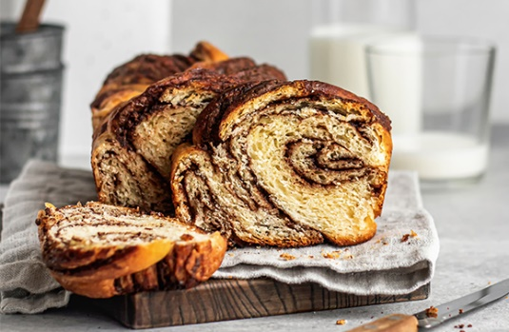
Banana and Chocolate Marble Loaf

Scaling of Ingredients
INGREDIENTS | % | grams | grams | grams
Cake flour | 100 | 1 000 | 12 500 | 25 000
Baking powder | 3,6 | 36 | 446 | 893
Eggs | 56,8 | 568 | 7 098 | 14 196
Vanilla essence | 1,8 | 18 | 223 | 446
Oil | 38,4 | 384 | 4 799 | 9 598
Salt | 0,9 | 9 | 110 | 220
Banana | 87,5 | 875 | 10 938 | 21 875
Milk | 28,6 | 286 | 3 571 | 7 143
Chocolate Marble
Cocoa powder | 2,5 | 25 | 313 | 625
Sugar | 4 | 41 | 515 | 1 030
Boiling water | 9 | 89 | 1 116 | 2 232
Total weight ± | 3 | 330 | 52 524 | 83 259
Makes |  | 3,5 loaves | 44 loaves | 89 loaves

Method:
- Preheat the oven to 170℃ and grease 23 cm loaf pans.
- In a mixer, whisk the oil and sugar until combined, adding in eggs individually, beat until light and creamy. Add in the vanilla essence, stir in the mashed bananas and milk.
- Add the cake flour, baking powder and salt into the egg mixture. Gradually add the milk and stir until just combined. Set it aside.
- For the chocolate marble, mix the cocoa, sugar, and water in a mixer.
- Pour 1/2 of the banana mixture into the pans. Top the batter evenly with small dollops of the chocolate marble mixture, top with remaining banana mixture. Repeat the process with chocolate mixture. Pull a table knife through the batter to create a marble effect.
- Bake for 50-60 minutes, or until when, a skewer is inserted it comes out clean.
- Leave the loaves to cool for 5 minutes before removing from pan.

Variations, Hints and Tips:
- Add 0,5% ground cinnamon to the dry ingredients.
- for a plain banana loaf, the chocolate marble may be omitted from the recipe.

